Excercise 3 – Tic-Tac-Toe Game using Minimax and AlphaBeta Pruning Search

Aim: Implement a Tic-Tac-Toe Game using Minimax and Alpha-Beta Pruning Search Methods

Source Code

import math

class TicTacToeGame:

def __init__(self):
self.board = [' ' for _ in range(9)]
self.human = 'X'
self.ai = 'O'
self.current_player = self.human
self.states_explored = 0

def display_board(self):
print("\n-------------")
for i in range(0, 9, 3):
print(f"| {self.board[i]} | {self.board[i+1]} | {self.board[i+2]} |")
print("-------------")
print()

def is_moves_left(self, board) -> bool:
if (' ' in board):
return True
else:
return False

def check_winner(self, board, player):
winning_combos = [
(0, 1, 2), (3, 4, 5), (6, 7, 8), #row
(0, 3, 6), (1, 4, 7), (2, 5, 8), #column
(0, 4, 8), (2, 4, 6) #diag
]

for a, b, c in winning_combos:
if board[a] == board[b] == board[c] == player:
return True
return False

def is_terminal(self, board):
return (self.check_winner(board, self.ai) or
self.check_winner(board, self.human) or
not self.is_moves_left(board))

def utility(self, board) -> int:
if self.check_winner(board, self.ai):
return 1
elif self.check_winner(board, self.human):
return -1
else:
return 0

def generate_successor_states(self, board, player):
successors = []
for i in range(9):
if board[i] == ' ':
new_state = list(board)
new_state[i] = player
successors.append(new_state)
return successors

def minimax(self, board, depth, is_maximizing):
self.states_explored += 1

score = self.utility(board)

if self.is_terminal(board):
return score

if is_maximizing:
best_val = -math.inf
successors = self.generate_successor_states(board, self.ai)
for state in successors:
value = self.minimax(state, depth + 1, False)
best_val = max(best_val, value)
return best_val
else:
best_val = math.inf
successors = self.generate_successor_states(board, self.human)
for state in successors:
value = self.minimax(state, depth + 1, True)
best_val = min(best_val, value)
return best_val

def alpha_beta(self, board, depth, alpha, beta, is_maximizing):
self.states_explored += 1

if self.is_terminal(board):
return self.utility(board)

if is_maximizing:
best_val = -math.inf
successors = self.generate_successor_states(board, self.ai)

for state in successors:
value = self.alpha_beta(state, depth + 1, alpha, beta, False)
best_val = max(best_val, value)
alpha = max(alpha, best_val)

if beta <= alpha:
break
return best_val
else:
best_val = math.inf
successors = self.generate_successor_states(board, self.human)

for state in successors:
value = self.alpha_beta(state, depth + 1, alpha, beta, True)
best_val = min(best_val, value)
beta = min(beta, best_val)

if beta <= alpha:
break
return best_val

def find_best_move(self, algo):
self.states_explored = 0

best_val = -math.inf
best_move = -1

for i in range(9):
if self.board[i] == ' ':
self.board[i] = self.ai

if (algo == 1):
move_val = self.minimax(self.board, 0, False)
else:
move_val = self.alpha_beta(self.board, 0, -math.inf, math.inf, False)

self.board[i] = ' '

if move_val > best_val:
best_move = i
best_val = move_val

print(f"States explored: {self.states_explored}")
return best_move

def play_game(self):
print("<- Tic-Tac-Toe ->")

algo = int(input(f"Minimax (1) or AlphaBeta Pruning (2): "))
print("\nYou are 'X' and the AI is 'O'.")
print("Enter positions 0-8 to play.")
self.display_board()

while not self.is_terminal(self.board):
if self.current_player == self.human:
while True:
try:
user_input = input(f"Enter move for {self.human} (0-8): ")
move = int(user_input)
if 0 <= move <= 8 and self.board[move] == ' ':
self.board[move] = self.human
self.current_player = self.ai
break
else:
print("Invalid move.")
except ValueError:
print("Please enter a valid integer between 0 and 8.")
else:
move = self.find_best_move(algo)
self.board[move] = self.ai
self.current_player = self.human
print(f"AI placed at pos {move}")

self.display_board()

if self.check_winner(self.board, self.ai):
print("Game Over. AI Wins!")
elif self.check_winner(self.board, self.human):
print("Game Over. You Win!")
else:
print("Game Over. It's a Draw!")

if __name__ == "__main__":
game = TicTacToeGame()
game.play_game()

Input/Output

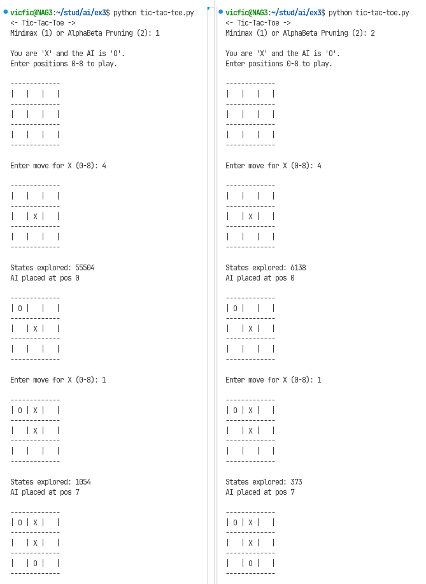
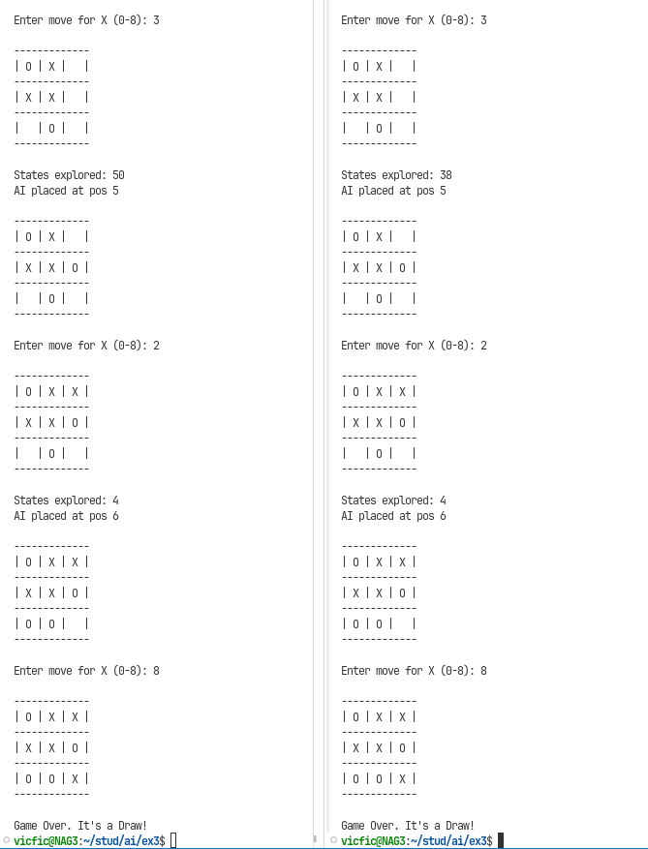

Learning Outcomes

- Implemented the Minimax and Alpha-Beta Pruning Search Methods.
- Learned to write a algorithmic opponent in an adversarial environment
- Understood the efficiancy that the Alpha Beta Pruning approach has over general Minimax in the amount of states explored.

