Excercise 2 – Implement Informed Search Strategy – A* Searach

Aim: Implement Informed Search Strategy – A* Searach for Emergency Evacuation Planning in a Building Grid

Source Code

import heapq

class Search_problem:
def start_node(self):
pass
def is_goal(self, node):
pass
def neighbors(self, node):
pass
def heuristic(self, node):
return 0

class Edge:
def __init__(self, from_node, to_node, action=None, cost=1):
self.from_node = from_node
self.to_node = to_node
self.action = action
self.cost = cost
if self.cost < 0:
raise ValueError("Edge cost must be non-negative.")

def __repr__(self):
return f"Edge({self.from_node} -> {self.to_node}, cost={self.cost})"

class GridSearchProblem(Search_problem):
def __init__(self, grid_str):
self.grid = [list(line) for line in grid_str.strip().split('\n')]
self.rows = len(self.grid)
self.cols = len(self.grid[0])
self.start = None
self.exits = []

# To find Start and Exits
for r in range(self.rows):
for c in range(self.cols):
if self.grid[r][c] == 'S':
self.start = (r, c)
elif self.grid[r][c] == 'E':
self.exits.append((r, c))

def start_node(self):
return self.start

def is_goal(self, node):
return node in self.exits

def neighbors(self, node):
r, c = node
moves = [(-1, 0, 'Up'), (1, 0, 'Down'), (0, -1, 'Left'), (0, 1, 'Right')]
result = []

for dr, dc, action in moves:
nr, nc = r + dr, c + dc
if 0 <= nr < self.rows and 0 <= nc < self.cols:
if self.grid[nr][nc] != '#':
result.append(Edge(node, (nr, nc), action, cost=1))
return result

def heuristic(self, node):
if not self.exits:
return 0
r, c = node
distances = [abs(r - er) + abs(c - ec) for er, ec in self.exits]
return min(distances)

class Path:
def __init__(self, start_node=None, parent_path=None, edge=None):
if parent_path is None:
self.last_node = start_node
self.parent_path = None
self.cost = 0 # g(n)
else:
self.last_node = edge.to_node
self.parent_path = parent_path
self.cost = parent_path.cost + edge.cost

def end(self):
return self.last_node

def __repr__(self):
nodes = []
current = self
while current:
nodes.append(str(current.last_node))
current = current.parent_path
nodes.reverse()
return f"Path(len={self.cost}, nodes={nodes})"

class Searcher:
def __init__(self, problem):
self.problem = problem
self.nodes_expanded = 0

def search(self):
print("Starting A* Search...")
start = self.problem.start_node()
initial_path = Path(start_node=start)

frontier = []
tie_breaker_index = 0

# f(n) = g(n) + h(n)
initial_h = self.problem.heuristic(start)
initial_f = initial_path.cost + initial_h

heapq.heappush(frontier, (initial_f, tie_breaker_index, initial_path))
tie_breaker_index += 1

explored = set()

while frontier:
f_val, _, current_path = heapq.heappop(frontier)
current_node = current_path.end()

if current_node in explored:
continue

explored.add(current_node)
self.nodes_expanded += 1

if self.problem.is_goal(current_node):
print(f"Goal met! Nodes expanded: {self.nodes_expanded}")
return current_path

neighbors = self.problem.neighbors(current_node)

for edge in neighbors:
child_node = edge.to_node
if child_node not in explored:
new_path = Path(parent_path=current_path, edge=edge)

g_score = new_path.cost
h_score = self.problem.heuristic(child_node)
f_score = g_score + h_score

heapq.heappush(frontier, (f_score, tie_breaker_index, new_path))
tie_breaker_index += 1

return None

if __name__ == "__main__":
grid1_str = """
S . . . . . .
# # # # # # .
. . . . . # .
. # # # . # .
. . . # . # E
. # . # . . .
. # . . . . .
"""
print("Test Case: GRID 1")
problem = GridSearchProblem(grid1_str)
searcher = Searcher(problem)
result = searcher.search()
if result:
print(f"Final Path Cost: {result.cost}")
print(f"Final Path: {result}")
else:
print("No path found")

print()

grid2_str = """
S . . . . . . . .
# # # # # . # # #
. . . . # . . . #
. # # . # # # . #
. # . . . . . . .
. # . # # # # # .
. . . . . . . . .
# # # # # . # # #
. . . . . . . . E
"""
print("Test Case: GRID 2")
problem = GridSearchProblem(grid2_str)
searcher = Searcher(problem)
result = searcher.search()
if result:
print(f"Final Path Cost: {result.cost}")
print(f"Final Path: {result}")
else:
print("No path found")

Input/Output

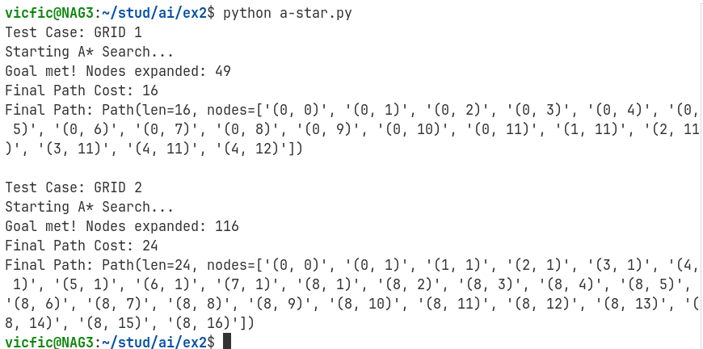

Learning Outcomes

- Implemented the A* algorithm using Python's heapq.
- Learn to properly represent grid search problems using recursive path structures and abstract base classes.
- Understood the importance of priority queues in efficiently managing the search frontier to guarantee optimal solutions

