Excercise 1b – Uninformed Search Strategy - Uniform Cost Search

Aim: Implement Uniform Cost Search (UCS)

Source Code

import heapq

class Search_problem:
def start_node(self):
pass
def is_goal(self, node):
pass
def neighbors(self, node):
pass
def heuristic(self, node):
return 0

class Edge:
def __init__(self, from_node, to_node, action=None, cost=1):
self.from_node = from_node
self.to_node = to_node
self.action = action
self.cost = cost
if self.cost < 0:
raise ValueError("Edge cost must be non-negative.")

def __repr__(self):
action_str = f", action={self.action}" if self.action is not None else ""
return f"Edge({self.from_node} -> {self.to_node}{action_str}, cost={self.cost})"

class Search_problem_from_explicit_graph(Search_problem):
def __init__(self, nodes, edges, start, goals, heuristics=None):
self.nodes = set(nodes)
self.edges_list = edges
self.start = start
self.goals = set(goals)
self.heuristics_map = heuristics if heuristics else {}

self.adjacency_list = {node: [] for node in self.nodes}
for edge in self.edges_list:
if edge.from_node in self.adjacency_list:
self.adjacency_list[edge.from_node].append(edge)

def start_node(self):
return self.start

def is_goal(self, node):
return node in self.goals

def neighbors(self, node):
return self.adjacency_list.get(node, [])

def heuristic(self, node):
return self.heuristics_map.get(node, 0)

class Path:
def __init__(self, start_node=None, parent_path=None, edge=None):
if parent_path is None:
self.last_node = start_node
self.parent_path = None
self.incoming_edge = None
self.cost = 0
else:
self.last_node = edge.to_node
self.parent_path = parent_path
self.incoming_edge = edge
self.cost = parent_path.cost + edge.cost

def end(self):
return self.last_node

def __repr__(self):
nodes = []
current = self
while current:
nodes.append(str(current.last_node))
current = current.parent_path
nodes.reverse()
path_str = " -> ".join(nodes)
return f"Path([{path_str}], total_cost={self.cost})"

class Searcher:
def __init__(self, problem):
self.problem = problem

def search(self):
print("Starting Search")
start = self.problem.start_node()
initial_path = Path(start_node=start)

frontier = []
tie_breaker_index = 0

heapq.heappush(frontier, (0, tie_breaker_index, initial_path))
tie_breaker_index += 1

explored = set()

while frontier:
path_cost, _, current_path = heapq.heappop(frontier)

print(f"\nExploring: {current_path}")

current_node = current_path.end()

if current_node in explored:
print(f" Node {current_node} already explored, skipping.")
continue

explored.add(current_node)

if self.problem.is_goal(current_node):
print(" Goal condition met!")
return current_path

neighbors = self.problem.neighbors(current_node)
if not neighbors:
print(" No neighbors found.")

for edge in neighbors:
print(f" Processing neighbor via: {edge}")

child_node = edge.to_node
if child_node not in explored:
new_path = Path(parent_path=current_path, edge=edge)

heapq.heappush(frontier, (new_path.cost, tie_breaker_index, new_path))
tie_breaker_index += 1

return None

if __name__ == "__main__":
nodes_set = {'A', 'B', 'C', 'D', 'E', 'F', 'G', 'H', 'J'}

edges_list = [
Edge('A', 'C', cost=3),
Edge('A', 'B', cost=2),
Edge('A', 'D', cost=4),
Edge('C', 'J', cost=7),
Edge('B', 'E', cost=2),
Edge('B', 'F', cost=3),
Edge('F', 'D', cost=2),
Edge('D', 'H', cost=4),
Edge('H', 'G', cost=3),
Edge('J', 'G', cost=4)
]

heuristics = {
'A': 7,
'B': 5,
'C': 9,
'D': 6,
'E': 3,
'F': 5,
'G': 0,
'H': 3,
'J': 4
}

problem_instance = Search_problem_from_explicit_graph(
nodes=nodes_set,
edges=edges_list,
start='A',
goals={'G'},
heuristics=heuristics
)

searcher = Searcher(problem_instance)
result_path = searcher.search()

print()
if result_path:
print("Success:", result_path)
else:
print("No path found.")

Input/Output

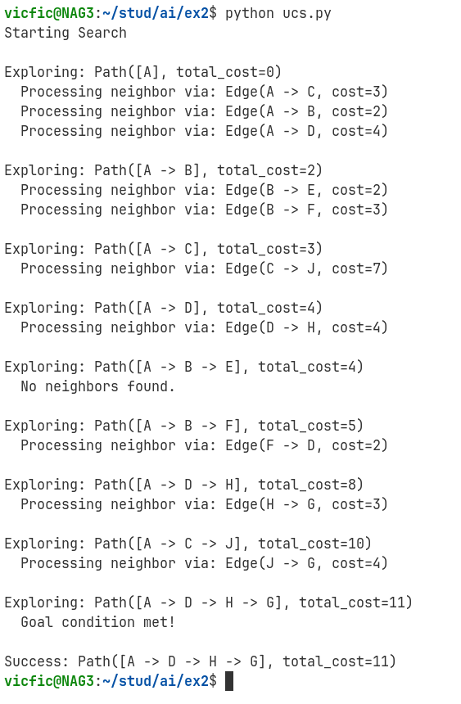

Learning Outcomes

- Implemented the Uniform Cost Search (UCS) algorithm using Python's heapq.
- Learn to properly represent graph search problems using recursive path structures and abstract base classes.
- Understood the importance of priority queues in efficiently managing the search frontier to guarantee optimal solutions

